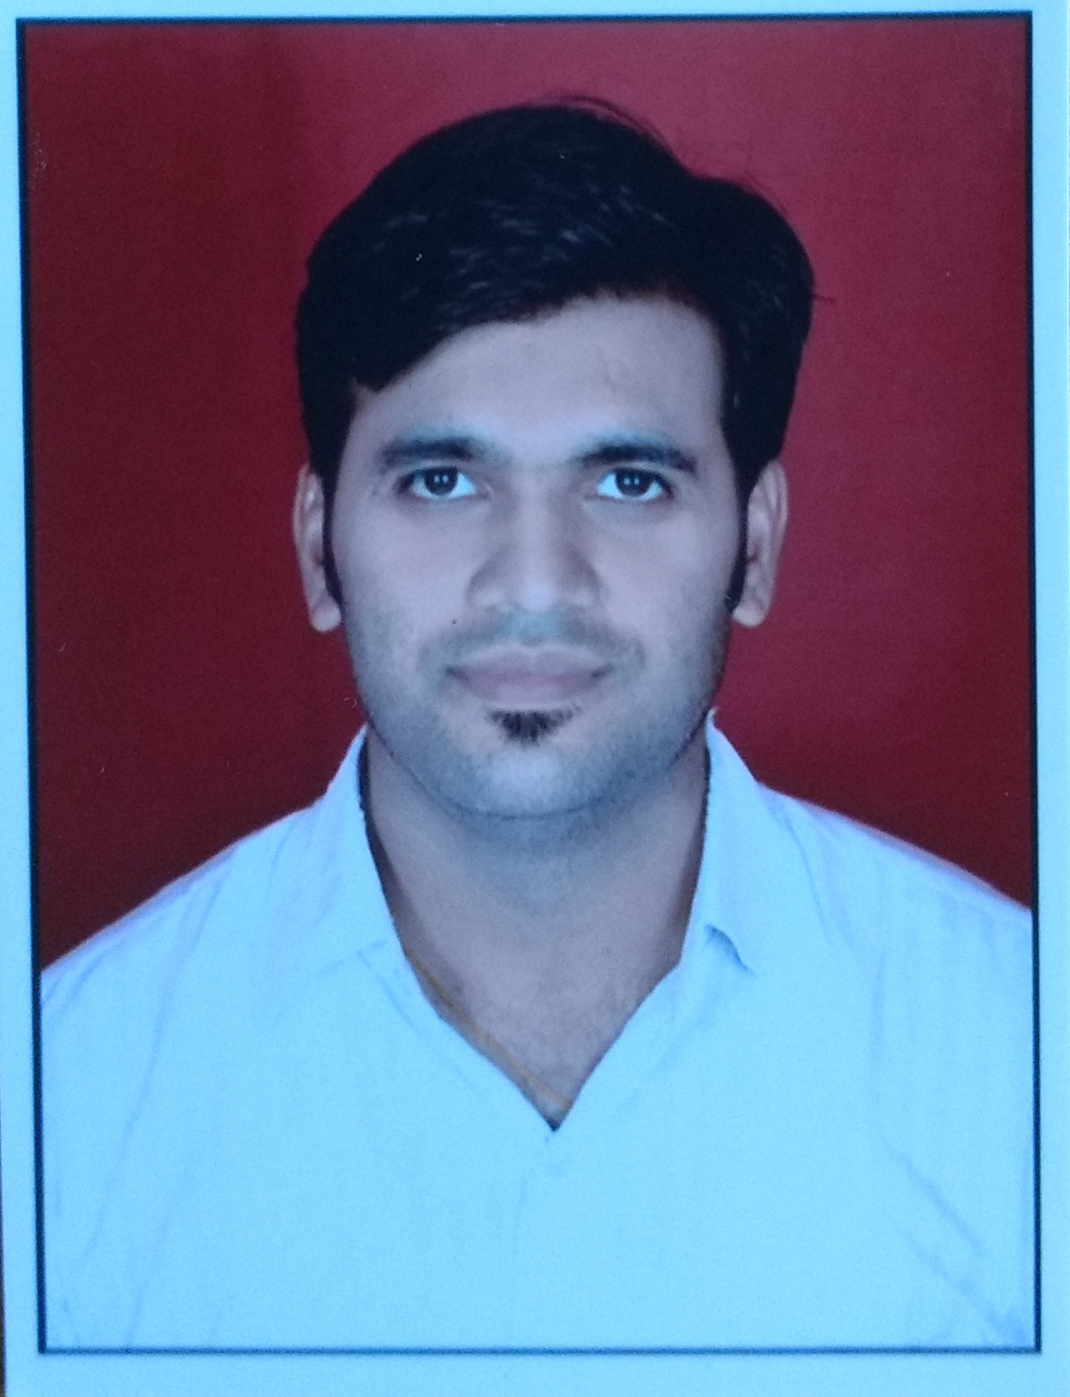
JECRC
JAIPUR

INDIVIDUAL FACULTY DATA SHEET
Name of the faculty member | : | Jitesh Kumar Jain
Present Designation | : | Asst.Professor
Email Id:jiteshjain.ce@jecrc.ac.in
Contact Details:9829906028

I. Particulars of Educational Qualification: (only completed)

Category | Name of the Degree | Specialization | Year of Passing | Name of the College | Name of the University
UG | B.E | Civil Engg. | 2008 | MBM Engg College | JNVU
PG
Ph.D.

II. Academic Experience : 2 Years & 4 months

III. Industrial Experience :7.0 Years

IV. Title of Ph.D. Thesis :Nil

V. Awards/Achievements : Nil

VI. Research/Specialization : Nil

VII. Course Taught : Theory of Structure,QSV,Advance Transportation
Engg,AutoCad

VIII. Refereed International Journal Publication : Nil

IX. International Conference Proceeding :Nil

X. Books Written : Nil

XI. M.Tech Thesis Guide : Nil

XII. PHD Thesis Guide :Nil

XIII. Professional Body Membership : Nil

